**Image Processing and Machine Vision**

**EN3160 Assignment 2 on Fitting and Alignment**

**210222U HEWAGAMAGE K.L.N**

<https://github.com/KumalHewagamage/Image-Fitting-and-Alignment>

**Task 1 - Blob Detection**

𝜎 = 𝑟/√2 relationship is used to calculate the radius of blob. Both Laplacian of gaussian and Determinant (LoG) of Hessian (DoH) were used for blob detection. Out of two methods, DoH provided the best results. For both methods *min_sigma=1, max_sigma=10, num_sigma=20* were used.

# Detect blobs using Laplacian of Gaussian (LoG) method

blobs_log = blob_log(gray,min_sigma=1, max_sigma=10, num_sigma=20, threshold=0.1)

blobs_log[:, 2] = blobs_log[:, 2] * np.sqrt(2)  # Convert sigma to radius

# Detect blobs using Determinant of Hessian (DoH) method

blobs_doh = blob_doh(gray, min_sigma=1, max_sigma=10, num_sigma=20, threshold=0.01)

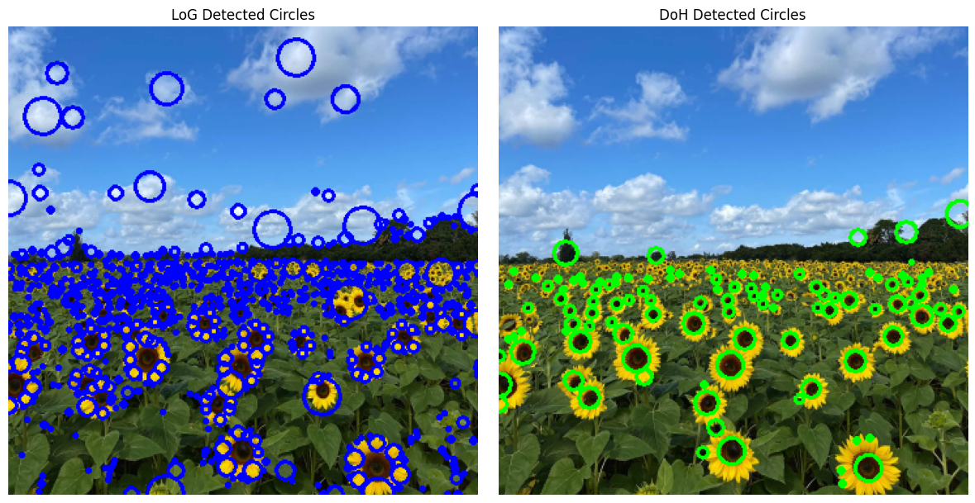

Largest circle using LoG: Center=(153.00, 271.00), Radius=14.14

Largest circle using DoH: Center=(255.00, 105.00), Radius=10.00

**Task 2 - Fitting Using RANSAC**

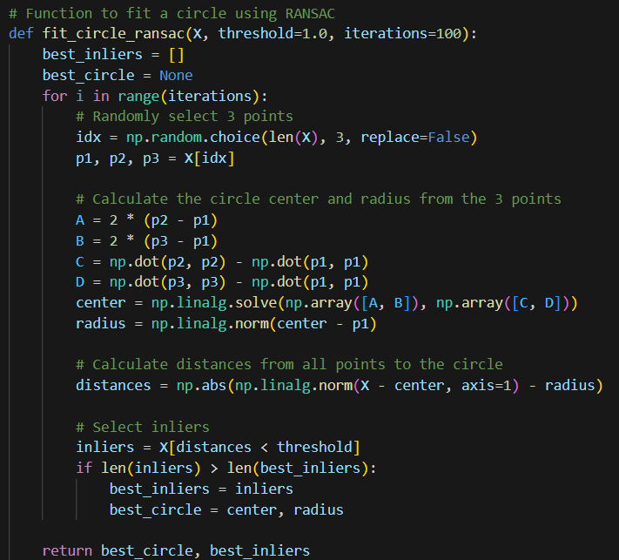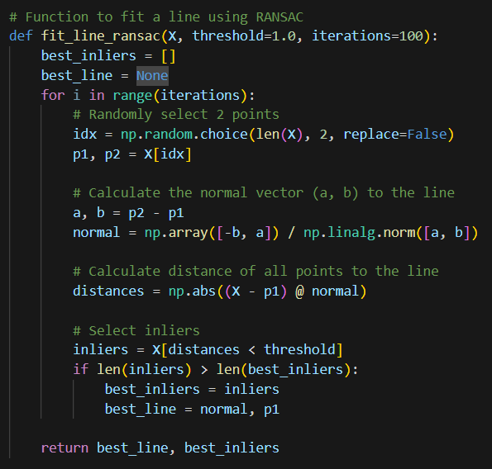

|  |  |  |
| --- | --- | --- |
| **Parameter** | **Line** | **Circle** |
| S: Minimum number of points required to uniquely define the shape | 2 | 3 |
| t: Error threshold | 1.0 | 1.0 |
| Iterations | 100 | 100 |

In this approach, the line is fitted first using RANSAC, and the inliers are then removed to allow fitting the circle. If the circle fitting were performed first, there could be a possibility that the three randomly selected points might be on the line, resulting in a large, inaccurate circle resembling a line. Fitting the line first helps in excluding the linear points, making it easier to subsequently fit the circle to the remaining data.

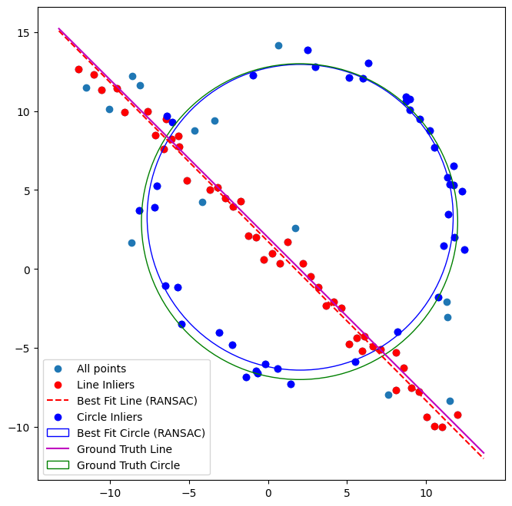

Best Fit Line:

Normal=[-0.71003654 -0.70416484],

Point on Line=[ 6.6122449 -4.91742667]

Best Fit Circle:

Center=[2.0370331 3.27607264], Radius=9.679013715560805

**Task 3 - Superimposing An Image On Another Image**

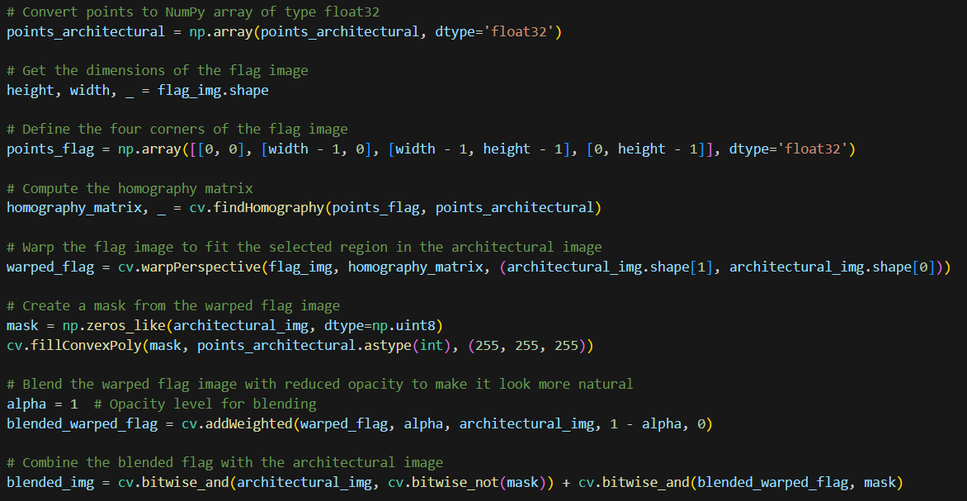

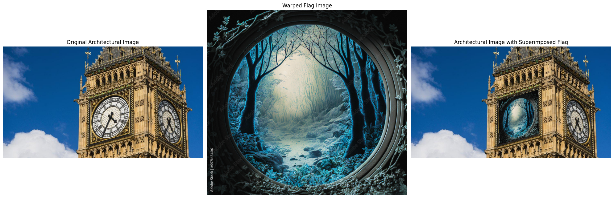

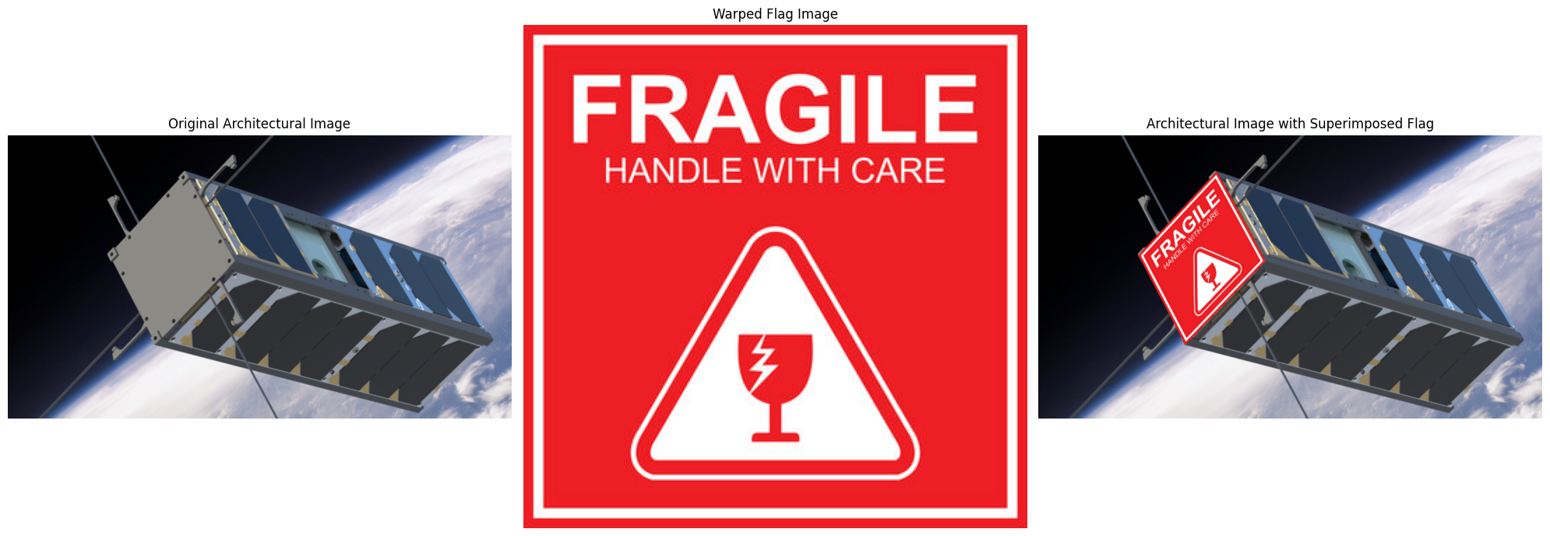

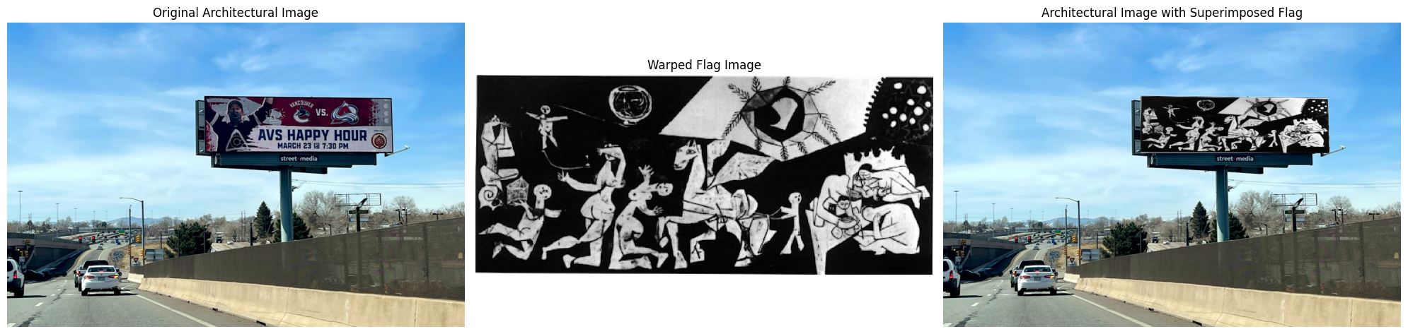

In this code homography matrix is computed between the four corners of the flag image and the selected points on the architectural image, allowing for alignment of the flag (or another image) with the target region. The flag image is then warped using this matrix, transforming it to fit the perspective of the selected area. A mask is created to define the target region, and the warped flag image is blended with the architectural image. Finally, the blended flag is combined with the original architectural image.

**Task 4 - Image Stitching**

def get_sift_features(img1, img2):

    # Convert to grayscale

    img1_gray = cv.cvtColor(img1, cv.COLOR_RGB2GRAY)

    img2_gray = cv.cvtColor(img2, cv.COLOR_RGB2GRAY)

    # Get SIFT descriptors

    sift = cv.SIFT_create(nOctaveLayers=3, contrastThreshold=0.09, edgeThreshold=25, sigma=1)

    keypoints1, descriptors1 = sift.detectAndCompute(img1_gray, None)

    keypoints2, descriptors2 = sift.detectAndCompute(img2_gray, None)

    # Match using Brute Force Matcher

    bf = cv.BFMatcher()

    matches = bf.knnMatch(descriptors1, descriptors2, k=2)

    # Lowe's ratio to filter best matches

    best_matches = []

    for m, n in matches:

        if m.distance < 0.75 * n.distance:

            best_matches.append(m)

    return best_matches, keypoints1, keypoints2

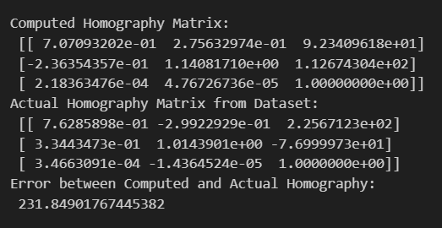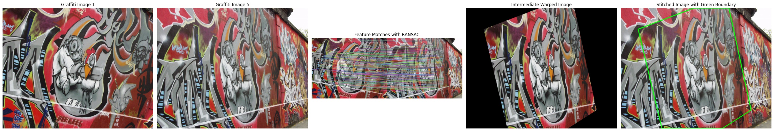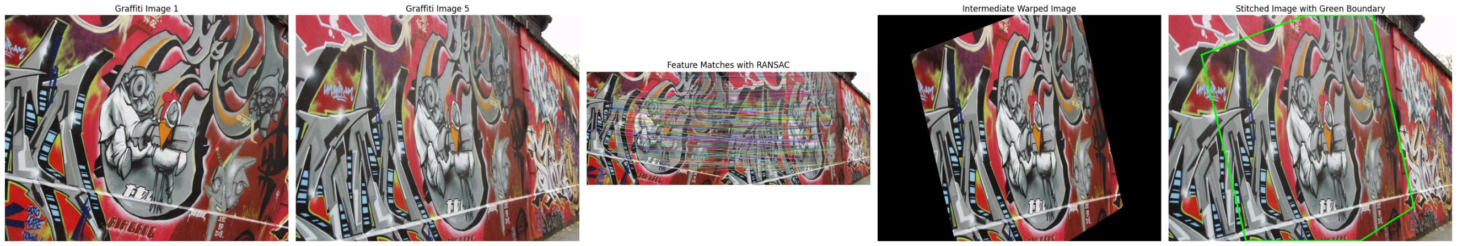Due to different perspective there not much feature to match with 1 and 5. Therefore we can see significant error in too homography matrices. This error is much lower in other image pairs.